**Brigg Sixth Form**

**A-Level**

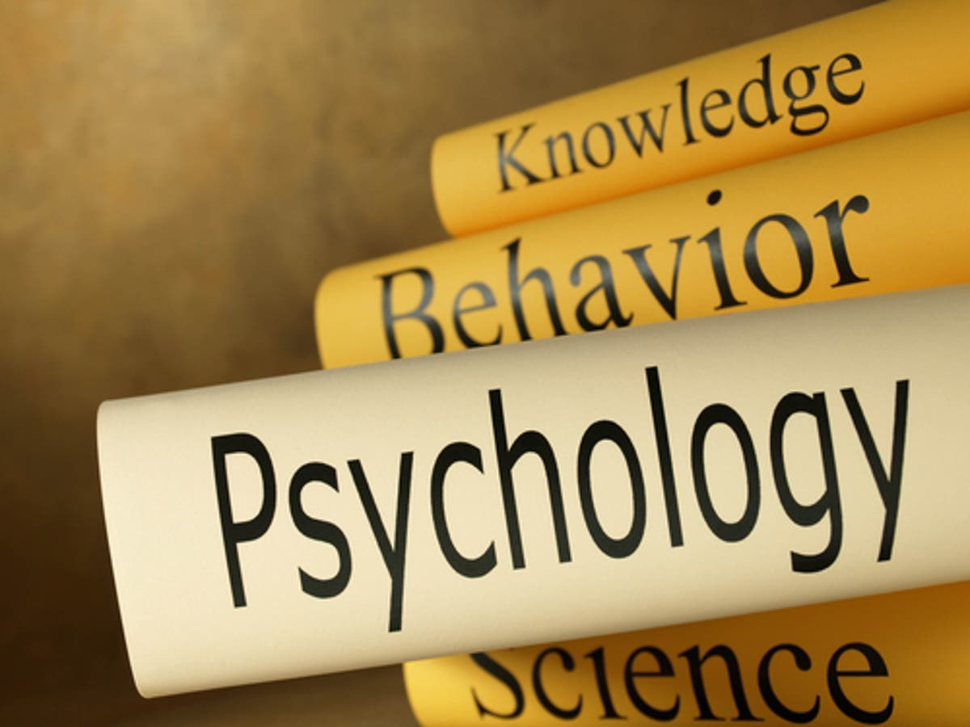**Transition Project**

**(Summer)**

**Introduction**

Psychology is the science of mind and behaviour. People study psychology because they want to know what makes people ‘tick’. Scientific methods such experiments from the natural sciences such as chemistry or biology are often used – however, this is not always possible when studying human participants. One of the methods psychologists use to study behaviour is observation and this is what I’d like you to have a go at over the summer.

**Task**

Your task is to plan and carry out some research using the observational method. Using the internet to find definitions of key terms, you will develop an understanding of the observational method, including different types of observation along with their strengths and weaknesses. You will then create your own observational checklist to use on your family (e.g. eating lunch or watching TV, pet or any TV progamme. I have included a sample checklist that you can edit and use if you prefer. You need to decide the following:-

Overt or covert observation

Participant or non participant

Your observation will most likely be naturalistic and, if you use a behaviour checklist to record data (the easiest way of doing it) it will be structured.

To keep it simple, only have 5-10 categories of behaviour (you could do a pilot study or ‘mini’ observation to help decide what these are before doing your main study)

You need to decide whether to use time (e.g. every 30 seconds for 10 minutes) or event sampling where you record the event(s) each and every time they occur.

You can then count up how many times each category of behaviour occurred and make a bar chart to summarise your findings.

**When is it required by?:**

Please bring this to the first lesson in September

**To extend your knowledge:**

Use the internet to research other research methods used by psychologists and summarise the strengths and weaknesses of each.

**Who to contact for help:**

**hopkinsonj@valeacademy.org.uk**