**Brigg Sixth Form**

**A-Level**

**Transition Project**

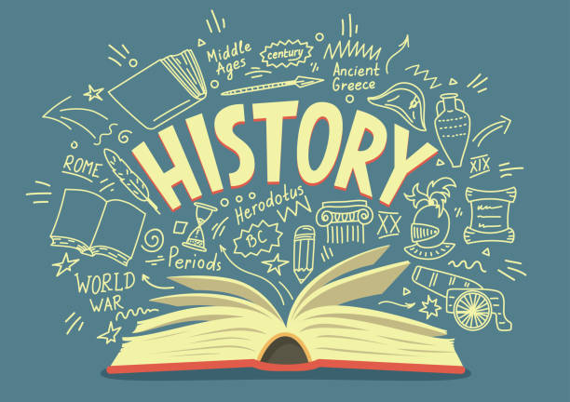

**(Summer)**

The Cold War 1941-1991

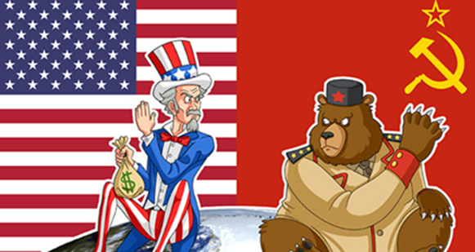

What does the specification require me to know?

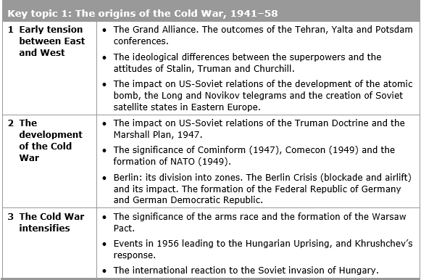

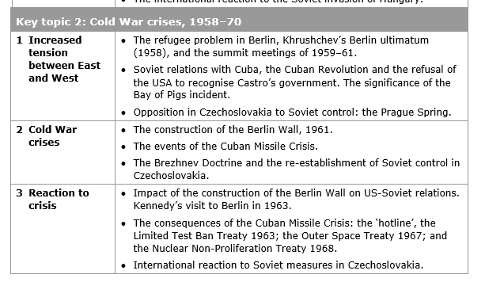

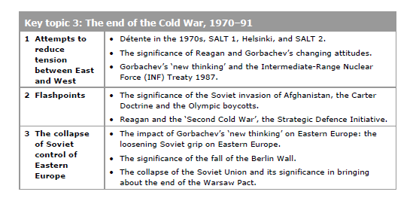

How do I revise?

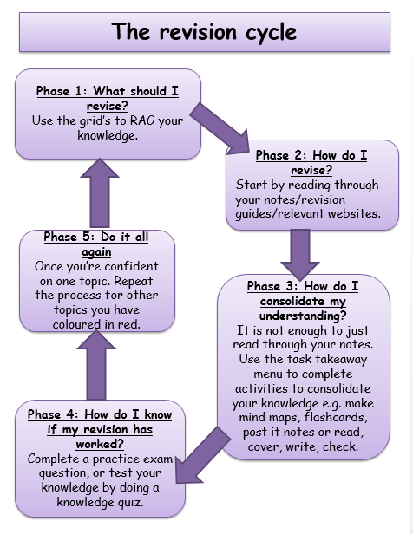

**How could I revise?**

‘**Brain dumps’**

Take a big piece of paper or a whiteboard, and write down everything you can remember about the topic you are revising e.g. Hungarian Uprising 1956

You could write down:

* Dates
* Names of individuals
* Key events
* Important place names
* Consequences
* Any other important information

Once you are happy that you cannot remember any more, use different colours to highlight or underline the words in groups. E.G. If revising Cuban Missile Crisis you may choose to underline all the mentions that relates to the causes in red, and to the effects in blue

**Learning walks**

Make use of your space! Write down key facts and place them around your home, where you will see the every day. Make an effort to read the facts whenever you walk past them.

**Distilling**

Memory studies show that we retain information better if we visit it regularly. This means that revising the information once is not necessarily going to help it stay in your brain. Going back over the facts at intervals of less than a week leads to the highest retention of facts.

To make this process streamlined, try distilling your notes. Start by reading over the notes you’ve completed in class, two days later read over them again, and then write down anything you did not remember. If you repeat this process enough you will end up with hardly any facts left to write down, because they will be stored in your brain

**Using your own downtime**

There are always little pockets of time through the day which are not good for anything – bus journeys, queues, ad breaks in TV programmes, waiting for the shower to heat up etc. If you add all of these minutes up it would amount to quite a lot of time, which could be put to good use for revision. You could photograph your revision notes, or record yourself saying your notes out loud.

**Cue cards**

Summarise key events onto que cards/A3 paper, and keep practicing. Practice past exam questions and quick quizzes.

**Who are the key leaders?**

|  |  |
| --- | --- |
| USSR | USA |
| Stalin 1924-1953 | Roosevelt 1933-1945  Truman 1945-1953 |
| Khrushchev 1955-1964 | Eisenhower 1953-1961  Kennedy 1961-1963 |
| Brezhnev 1964-1982 | Johnson 1963-1969  Nixon 1969-1974  Ford 1974-1977  Carter 1977-1981 |
| Gorbachev 1985-1991 | Reagan 1981-1989  Bush 1988-1993 |

It is important to know who the different leaders were at each point

Key topic 1: The origins of the Cold War, 1941 – 1958

1.1 Early tension between East and West

The Cold War was not like previous World Wars. America and the USSR never declared war on each other, nor did they face each other in battle. They both took part in proxy wars – that is they helped their allies to fight the other Superpower or their allies but did not become directly involved in the conflict themselves. This is because both sides knew that a Third World War, a Nuclear War would be unwinnable.

The Cold War was a race to become the biggest and strongest superpower, to prove once and for all that their ideology was the best. It did however have many characteristics of an actual war: arms race, alliances and propaganda.

**What were the different ideologies?**

. CAPITALISM VERSUS COMMUNISM….

|  |  |  |
| --- | --- | --- |
| **Ideology** | **Capitalism – Capitalist - WEST** | **Communism – Communist - EAST** |
| **Focus** | Individual Rights | Rights of the working class |
| **Values** | Individual Freedom | Equality |
| **Economy** | Free Trade | Government Planned |
| **Politics** | Democratic Elections | Dictator and Communist Party controls the government |

Both sides feared the other was out to destroy it. The Soviets believed the west was out to destroy communism. The West believed Soviets wanted to spread communism around the globe.

**Stalin’s Suspicion of the West**

The USSR had been attacked previously, Germany had invaded Russia in 1914, in 1918, Allied forces had invaded Russia during the Civil War. Hitler had invaded in 1941. Stalin believed it was essential to have friendly countries on his border to prevent this happening again.

Stalin did not trust the West. The West had been appeased Hitler in the 1930s - Stalin believed they had wanted Hitler to destroy communism. The West was also slow to open a Second Front during the Second World War to help the Russians fight Hitler.

*What was The Grand Alliance?*

The Grand Alliance was established by USSR, USA and Britain from 1941 to defeat the axis powers led by Germany, Japan and Italy. Following the end of the Second World War the Big 3 hoped to continue their friendship but as it became clearer that the Germany was defeated the Big 3 began to have conflicting aims and objectives.

**The conferences**

Tehran, November 1943

AIM:

Plan a strategy to win the war

AREAS OF AGREEMENT:

* USA and Britain would open a ‘second front’ easing pressure on the Eastern Front (Soviets = heavy losses)
* Stalin would declare war against Japan and supply Soviet troops to help the USA win the war against Japan BUT… only when the war in Europe was over
* Discussed what would happen to Germany after the war – no formal agreement BUT it was agreed that Germany should remain week
* An international body should be set up to settle disputes

IMPACT?

* Before the conference, Stalin felt that the USA and Britain were deliberately trying to delay the opening of a ‘second front’ so he was pleased with the agreement that there would be a ‘second front’
* Agreement between Stalin and Roosevelt over where the ‘second front’ should open
* Generally good relations between Roosevelt and Stalin

Yalta, February 1945

AIM:

Discuss winning the war and the government of post-war Europe

‘Second front’ had been launched in France

Soviets had defeated Germany in the Soviet Union and they had control of most of Central and Eastern Europe

AREAS OF AGREEMENT:

* Germany would be split into four zone – each controlled by a different power (USA, Britain, France and the Soviet Union)
* Germany would pay $20 billion in reparations
* Nazi Party banned and war criminals prosecuted
* United Nations would be set up
* Stalin agreed to join the war against Japan
* Stalin agreed that future governments of countries in Easter Europe would be decided in free elections

AREAS OF DISAGREEMENT:

* Stalin wanted all 16 Soviet republics to be given individual membership to the United Nations. Britain and France disagreed. Russia, the Ukraine and Belarus were admitted
* Issues over Poland – it was agreed that the borders of Poland should be returned to their position in 1921 (giving the USSR significant gains), and that there would be free elections. BUT… Stalin wanted to ensure a pro-Communist government came to power, whereas the British wanted the London Poles to be elected

Potsdam Conference, July-August 1945

IMPORTANT CHANGES SINCE YALTA:

Harry Truman had replaced Roosevelt. Truman was determined to take a get tough approach with Stalin and was very anti-Communist

Churchill had lost the election and was replaced by Clement Atlee. There were issues in Britain that Atlee needed to deal with and therefore he was rushing the discussions to get back to Britain.

Germany had surrendered in May 1945 – no common enemy

The USA had developed the atomic bomb

AREAS OF AGREEMENT:

* Germany would be divided into 4 zones
* Berlin would also be divided into 4 zones (even though Berlin was part of the Soviet zone)
* Each administering country should take reparations from its own zone
* Soviet Union had the poorest zone (which they hated). It was agreed that the Soviets could take a quarter of the industrial equipment from the other zones

AREAS OF DISAGREEMENT:

* Disagreements over the governments of Eastern Europe – how governments should be formed and who should rule them. Stalin wanted security for the USSR so he wanted there to be pro-communist governments
* How much reparations Germany should pay: the USSR wanted Germany to pay a significant amount, whereas the USA and Britain felt this would not be fair to Germany’s overall recovery.

**The Atomic Bomb**

On 16th August, during the Potsdam Conference, the USA successfully tested their first A Bomb. Truman informed Stalin about it, but was not willing to share the technology. This made Stalin even more suspicious of the West and encouraged him to begin an arms race to make the USSR’s weapons equal in force to those of the USA.

The Arms Race was pushed along by fear.

Until 1949 the USSR could not risk a war against USA. When the USSR exploded its own nuclear weapon in 1949 tension began to increase. The USA began to develop the H bomb. In 1952 the USSR exploded its own H-bomb. The USA began to build bomber aircraft, to deliver the H-bomb, in the mistaken belief that the USSR had more bomber aircraft than the USA did.

**The Secret Telegrams**

Truman and Stalin both feared the breakdown of the grand alliance and the subsequent threat of a new war. Both had secret reports from their embassies for information on the other leader and their plans. The reports were sent as telegrams.

The Long Telegram

Truman received a worrying telegram from Kennan – he was America’s ambassador in Moscow.

Kennan reported that:

•Stalin had given a speech calling for destruction of capitalism

•America could have no peace with Russia while it opposed capitalism

•Russia was building military power.

•The USA should seek to contain communism.

The Novikov telegram

Stalin received a worrying telegram from Novikov – he was the USSR’s ambassador in Washington.

Novikov reported that:

•America desired to dominate the world.

•Following Roosevelt’s death, the American government was no longer interested in co-operation with the USSR.

•The American public were being prepared for war with the USSR.

Following both telegrams, both countries believed that there was a great possibility of war. The USSR believed that war was inevitable whereas the Americans had labelled Stalin as 'the new Hitler'. By the end of 1946, the Grand Alliance was all but over. America believed the USSR were preparing for world domination and vice versa. This was the unofficial start of the Cold War.

Iron Curtain speech, 1946

In March 1946, Churchill made a speech in Fulton (USA) which stated that an ‘iron curtain had descended across the continent of Europe’ – the Iron Curtain being an imaginary line that divided the communist East from the capitalist West.

**The creation of Satellite States**

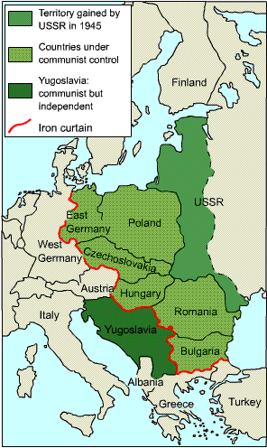The USSR responded to its nuclear inferiority by strengthening its control over Eastern Europe.

Rigged elections, violence, intimidation and other methods were used to gain control over Eastern European states including Bulgaria, Hungary, Poland and Romania.

By 1947 all eastern European states apart from Czechoslovakia had communist governments (Czechoslovakia came under communist government in 1948). No free elections had been held as agreed to at Yalta.

The USSR justified its actions;

* It had created a buffer zone against the West.
* It was afraid of the USA’s atomic power
* It was afraid of an attack by the West in the near future.
* It had created a ‘*sphere of influence’* as agreed at Yalta.

The USA claimed;

* The USSR had seized control of Eastern Europe and rejected free elections as agreed at Yalta.
* The USA feared that the USSR was determined to extend its influence into Western Europe (and then the rest of the world!!)

The USSR claimed that their measures were defensive, but the USA claimed they were aggressive and a threat to the west.

**1.2: The development of the Cold War:**

**Containment**

The Truman Doctrine

Between 1945 and 1949 the USA sought to contain the spread of communism, first in Europe but later around the globe. The USA believed that the USSR was determined to expand and that the USA should use any means possible to stop that expansion.

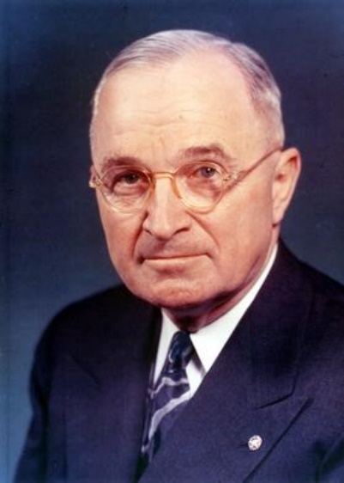Greece was the first country to benefit from this policy. During WW2 the Greek resistance to the German occupation had been divided into supporters of the monarchy and the communists. At the end of the war British troops had helped to restore the monarchy but were now under attack from the communists. By 1947, Britain could no longer afford to continue to keep troops in Greece and so they asked for help from the USA. The USA provided money to keep the British troops in Greece

“I believe that it must be the policy of the United States to support free peoples who are resisting attempted subjugation by armed minorities or by outside pressures.”

In 1947 President Truman outlined the USA’s response in what became known as the Truman Doctrine.

This policy was designed to stop the spread of communism - it was called containment

Policy was driven by a belief in the ‘Domino Theory' – the USA should prevent one country from falling to communism to stop others from following suit.

It was believed that it was America's duty to protect democracies from the threat of communism. It would do this by providing money, aid, advisors or even weapons to any country threatened by communism.

USA showed this policy in action when it installed ballistic missiles in Turkey - the USSR had no such missiles and therefore saw this action as hostile.

MC900054870[1]The Marshall Plan

The Marshall Plan is an economic extension of the Truman Doctrine

Europe’s economy had been shattered by WW2. Europe had to tackle the devastation caused by the war, the impact of the bombing, the loss of lives, the destruction of industry, refugees and a mountain of debt. Europe owed the USA $11.5 billion.

US Secretary of State George Marshall believed that countries suffering from poverty and unemployment were more likely to turn to communism. The aim of the Marshall Plan was therefore to rebuild the shattered European economy so that it could contain the spread of communism. A fund of $15 billion was made available to any nation who applied for it.

The Marshall Planaimed to:

* Raise living standards in Western Europe to reduce the appeal of communism.
* To rebuild Germany
* To weaken Soviet control over Eastern Europe
* To help the US economy by increasing US exports to Europe. They did not want a repeat of the 1920s.

The US government was initially insure about providing so much money to Europe, however, events in Czechoslovakia soon changed their minds.

Consequences of the Truman Doctrine

* Greek government was able to defeat the communists
* Rivalry between the USA and the Soviet Union increased. Truman had publicly stated that the world was divided with two different ways to live – the free and the unfree.
* The USA became committed to a policy of containment and far more involved in European affairs
* The USA decided to provide economic aid to Europe (Marshall Plan) although this was motivated by US self-interest
* In 1947, Stalin retaliated by setting up Cominform – a clear reaction and a clear development in the intensification of relations.

Consequences of the Marshall Plan

* By 1953, the USA had provided $17 billion to help European countries rebuild their economies and raise their standard of living. US machinery helped European factories to recover from the effects of the Second World War. US advisers helped to rebuild transport systems.
* Europe became more firmly divided between East and West. Stalin was initially involved but withdrew the Soviet Union from discussions because he did not trust the USA and did not want to show how weak the Soviet Union really was economically. He prevented eastern European countries, such as Czechoslovakia and Poland from becoming involved.
* Stalin accused the USA of using the Plan for its own selfish interests – to dominate Europe and boost the US economy.

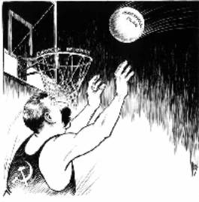**Stalin’s Reaction to the Marshall Plan**

Stalin called the Marshall Plan *‘dollar imperialism'* and claimed the USA was trying to control industry and trade in Europe. He believed that it sought to undermine communism and to promote the spread of capitalism across the globe. He refused to accept any economic aid and stopped any Eastern bloc country applying for it.

Cominform (1947) and Comecon (1949)

To try to prevent any eastern European countries applying for Marshall Aid, Stalin offered help and support to Eastern Europe by setting up two organisations**,** Cominform (1947) and Comecon (1949).

Cominform(Communist Information Bureau) was an alliance of European communist parties to help them plan and to work together and spread Stalin’s ideas. It increased the control Stalin had over these countries, and limited their independence. Only Marshal Tito, the communist leader of Yugoslavia, would not accept Stalin’s total leadership and split with Moscow.

Comecon(Council for Mutual Economic Aid) was set up to coordinate the production and trade of the eastern European communist countries. They were expected to trade with each other and not the West. However, it favoured the USSR more than any of its other members.

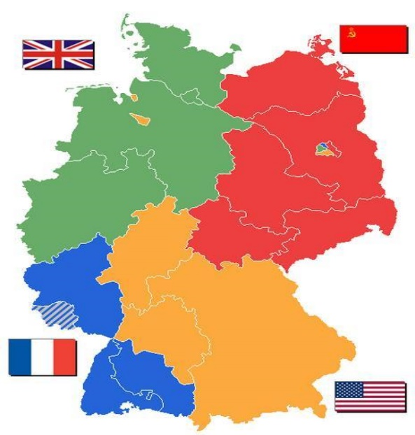**The Berlin Crisis (blockade): 1948-49**

Germany, and Berlin, had been divided in 1945 into zones of occupation. This was a source of tension which peaked during the Berlin Crisis of 1948-49.

Causes of the Berlin Crisis/Berlin Blockade:

* Britain, France and the USA had merged their zones of West Germany into one in March 1948
* Britain, France and the USA had then introduced a new currency called the **‘Deutsch mark’** to western Germany, which was intended to help it become economically stronger.
* There was a crisis as capitalism was drawing many people away from the communist east towards greater opportunities and freedoms in the west.

As a result:

* Stalin felt threatened by Germany’s growing strength
* Stalin was angry that the west had not consulted him before making changes in their zones of Germany
* Stalin wanted the ‘cancer’ of West Berlin to be removed from East Germany.

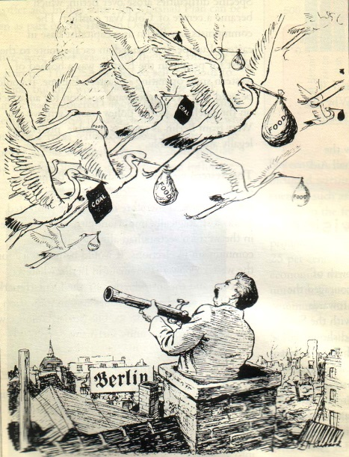What happened?

In June 1948 Stalin cut off all road, rail and canal links to West Berlin – the Berlin Blockade. The city only had 6 weeks supplies of food and fuel. Stalin aimed to starve the 2 million inhabitants in West Berlin into submission. He believed that Truman would either have to give up West Berlin or go to war.

But the West responded with a massive airlift - food, fuel and supplies were flown into Berlin for 10 months. Stalin dared no shoot down any planes – it would be an act of war. Stalin called off the Blockade in May 1949.

Outcomes/consequences:

* A propaganda victory for the West - Truman had shown he would not allow the policy of containment to fail.
* Stalin was humiliated - the USSR had failed to extend its influence
* The division of Germany into two separate states - in May 1949 the new Federal Republic of Germany (FRG) was set up. In October the eastern zone became the German Democratic Republic (GDR)
* The formation of NATO.
* Deepened hostility between East and West.

What were the consequences of the Berlin crisis?

* Confirmed the divisions of Germany and Berlin: western Allies announced that their former occupation zones (including Berlin) would form together to make the FRG
* Greatly increased East-West tensions: it was a victory for the West; massive humiliation for Stalin
* Led to the setting up of NATO: committed America to the defence of Europe

**What was NATO?**

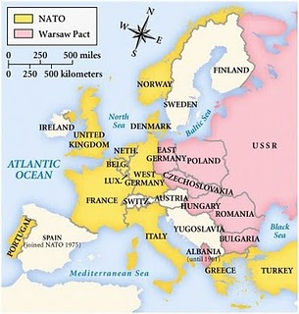The North Atlantic Treaty Organisation (NATO) was formed in April 1949 by the Western powers. This was during the period of the Berlin Blockade, and was partly in response to Stalin’s aggression. The original twelve members of NATO in 1949 were the United States, the United Kingdom, Canada, France, Denmark, Iceland, Italy, Norway, Portugal, Belgium, Netherlands, and Luxembourg. NATO was a military alliance that committed all members to the defence of all the others.

But NATO was more than a promise of American help in an emergency. The alliance was to be supported by large numbers of troops on the ground. In particular, there were a large number of troops in West Germany. By 1953, 5 divisions of US troops were permanently based there.

Stalin, unsurprisingly, saw NATO as a threat to the USSR and Eastern Europe.

What were the consequences of the setting up of NATO?

* The USA was now fully committed to the defence of Western Europe – instead of isolating herself from European affairs
* Stalin believed it was aimed against the Soviet Union; increasing tensions
* Intensified the arms race between the two sides and the development of weapons of destruction
* The Soviet Union set up the Warsaw Pact within 6 years – a military treaty protecting the USSR and the satellite states
* USA set up its own missile bases in western Europe

What was the Warsaw Pact?

The Warsaw Pact was set up in 1955. The Warsaw Pact was a defensive military alliance of the USSR and its satellite states in Eastern Europe. It was intended as a counter-force to NATO, which was a military alliance of western powers.

The Warsaw Pact, like NATO, relied on collective security – if one nation was attacked, the others would come to its support. The Warsaw Pact helped to make Eastern Europe an effective ‘buffer zone’ for the USSR against the West.

**Key Topic 1.3: The Cold War intensifies**

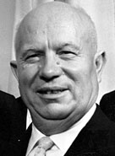**The death of Stalin**

Stalin died in 1953. After a short struggle for power, in 1955 Khrushchev became the new ruler of the USSR. At first, the western powers hoped that Khrushchev would be the start of a ‘thaw’ in the Cold War.

-Khrushchev met western leaders at ‘summit’ meetings and even travelled to the USA.

-In the ‘Secret Speech’ at the Twentieth Party Congress in 1956, Khrushchev attacked Stalin, saying that Stalin was a murderer and a tyrant. Khrushchev began to ‘de-Stalinize’ Russia - political prisoners were set free and the activities of the secret police were reduced.

-Khrushchev said that he wanted peaceful co-existence with the West. Western leaders hoped this meant the end of the Cold War.

Given hope that Stalin’s era of repression and fear had come to an end, opponents of communism in Eastern Europe began to make demands.

**The arms race**

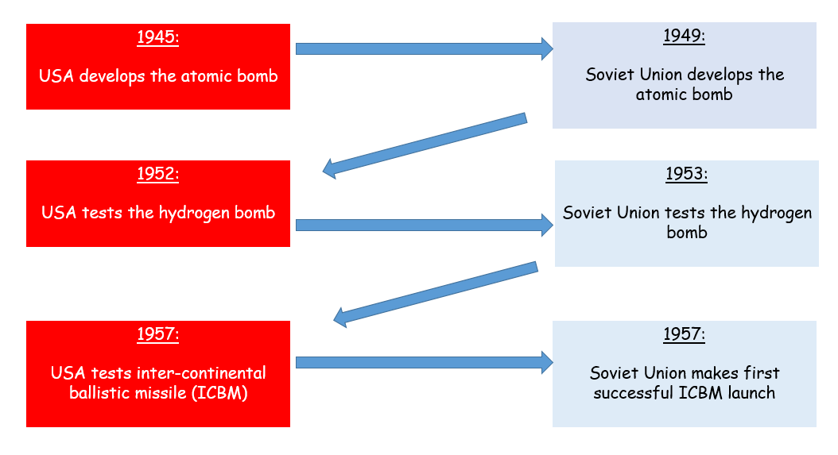

Why was the arms race important for the development of the Cold War?

* Balance of terror – could destroy the world many times over
* Each side felt threatened by the other
* Had to try and stay ahead of the game, be better than the other side
* Each side made more alliances and built more weapons
* Strained relations
* 1957 Sputnik was launched by the USSR; could orbit the earth in 1 ½ hours = military threat
* Increased tension as there was a constant fear of what could happen

There were also two new leaders… Khrushchev and Eisenhower.

Why was there hope that relations would now cool off?

* Change in leadership made people on both sides hopeful that tensions between the Soviet Union and USA could be reduced
* Solution to the Cold War arms race could be found
* 1950 war in Korea in which the USA and Soviet Union supported different sides – July 1953 it had ended
* USA and the Soviet Union spending large sums on their armed force. Reducing spending would be good for their economies.
* July 1955 Geneva summit meeting – agreement on how Austria should be governed
* Geneva failed to reach an agreement over disarmament and the future of Germany BUT the atmosphere of co-operation at the meeting reduced some of the tension
* May 1955 – West Germany joined NATO
* Soviets responded by the formation of the Warsaw Pact = still suspicion existing.

**The Hungarian Uprising, October 1956:**

* In 1956, the people of Hungary began to protest about their lack of political freedoms and problems created by fuel shortages and poor harvests
* October 1956, riots in Budapest
* Soviet troops restored order
* Khrushchev replaced Rakosi with Imre Nagy – Communist but believed there should still be personal freedoms
* Khrushchev hoped his appointment would end the protests
* Nagi announced a set of proposed reforms – reorganised the Hungarian government, to include members of non-Communist parties
* This ended the one-party state in Hungary
* Authorised the release of political prisoners and persuaded Khrushchev to withdraw Soviet troops from Hungary

Causes of the uprising

* Poverty: Hungarians were poor, yet much of the food and industrial goods they produced was sent to Russia.
* Russian Control: The Hungarians were very patriotic, and they hated Russian control – which included censorship, the vicious secret police and Russian control of what the schools taught. Religious issues: The Hungarians were a religious people, but the Communist Party had banned religion, and put the leader of the Catholic Church in prison.
* Help from the West: Hungarians thought that the United Nations or the new US president, Eisenhower, would help them.
* De-Stalinisation: When the Communist Party tried to de-Stalinise Hungary, things got out of control. The Hungarian leader Rakosi asked for permission to arrest 400 trouble-makers, but Khrushchev would not let him.

Events of the uprising

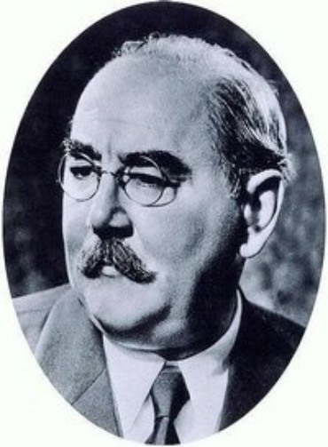- 23 October: Riots of students, workers and soldiers. They smashed up the statue of Stalin, and attacked the Secret Police and Russian soldiers.

- 24 October: Imre Nagy took over as Prime Minister. He asked Khrushchev to take Russian troops out of Hungary.

- 28 October: Khrushchev agreed, and the Russian army pulled out of Budapest.

- 29 October – 3 November: The new Hungarian government introduced democracy, freedom of speech, and freedom of religion (the leader of the Catholic Church was freed from prison). Nagy also announced that Hungary was going to leave the Warsaw Pact.

- 4 November: At dawn, 1000 Russian tanks rolled into Budapest. By 8.10 am they had destroyed the Hungarian army and captured Hungarian Radio – its last words broadcast were ‘Help! Help! Help!’ Hungarian people – even children – fought them with machine guns. Some 4000 Hungarians killed fighting the Russians.

- Khrushchev put in Janos Kadar, a supporter of Russia, as Prime Minister.

- Nagy was executed.

Outcomes/Consequences of the Hungarian Uprising:

1. 200,000 Hungarian refugees fled into Austria.
2. Russia stayed in control behind the Iron Curtain.
3. People in the West were horrified – many British Communists left the Communist Party.
4. It was clear to Eastern Europe that the West would not come to their aid to help them overturn communism.
5. However, whilst they would not intervene in countries that were within the Soviet sphere of influence, Western leaders became even more determined to ‘contain’ communism.
6. Khrushchev’s position became more secure in the Soviet Union. Stronger position in the Warsaw Pact
7. Members knew to do as they were told