**Brigg Sixth Form**

**A-Level**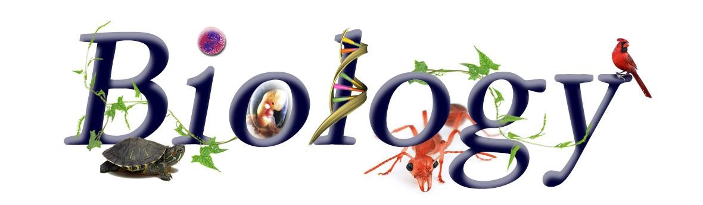

**Transition Project**

**(Summer)**

**A-Level Biology Transition**

**Research Project Part 1: Cell Structure**

**Background**

Cell theory is a unifying concept in biology and all life on Earth exists as cells. All cells have basic features in common and differences between cells are due to the addition of extra features. This provides indirect evidence for evolution.

All cells arise from other cells, by binary fission in prokaryotic cells and by mitosis and meiosis in eukaryotic cells. All cells have a cell-surface membrane and, in addition, eukaryotic cells have internal membranes.

The internal structure of eukaryotic cells is complex and they consist of distinct organelles, each of which has a specific function within the cell.

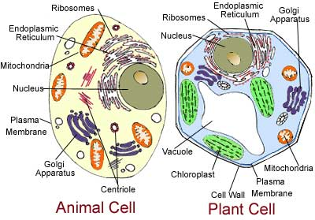

**Task**

Research the structure and function of the following organelles to complete the attached table:

1. cell-surface membrane
2. nucleus
3. mitochondria
4. chloroplasts (in plants and algae)
5. Golgi apparatus
6. lysosomes
7. ribosomes
8. endoplasmic reticulum
9. cell wall (in plants and algae)

**A-Level Biology Transition Project: Cell Structure**

|  |  |  |  |
| --- | --- | --- | --- |
| **Organelle** | **Size (µm or nm)** | **Function/ role in the cell** | **Key features/ adaptations which support its role** |
| **Nucleus** |  |  |  |
| **Mitochondrion** |  |  |  |
| **Chloroplast (plant cells only)** |  |  |  |
| **Cell membrane** |  |  |  |
| **Cell wall (plant cells only)**  M - Vokabular der mikroskopischen Anatomie - Vocabulary of microscopic  Anatomy |  |  |  |
| **Ribosomes**  Ribosomes and polyribosomes, TEM - Stock Image - C036/7388 - Science Photo  Library |  |  |  |
| **Endoplasmic reticulum**  Cell Structure and Organisation - Revision Notes in A Level and IB Biology |  |  |  |
| **Golgi apparatus**  Golgi Apparatus, Tem Photograph by Biophoto Associates |  |  |  |
| **Lysosome** |  |  |  |

**A-Level Biology Transition**

**Research Project Part 2: The Diversity of Life**

The following research project will act as a bridging topic and serve as a useful introduction to the diversity of life, providing some additional fundamental understanding to supplement knowledge gained at GCSE.

**Background**

We can develop a deep understanding of the evolutionary and ecological relationships which exist between organisms if we can classify them according to their key features and characteristics. All living things can be divided into 3 domains (Eukarya, Bacteria, Archaea) and the Eukarya are further subdivided into 4 major kingdoms (Animalia, Plantae, Fungi, Prototoctista).

An understanding of these major groups underpins much of biology and is essential to appreciate the richness and diversity of life on the planet earth.

**The activity…**

To complete this transition A-level project, you will be expected to research the fundamental features of each of the following groups: Bacteria, Animalia, Plantae, Fungi. You should prepare a one-page summary of the main characteristics exhibited by all members of the group. This should include the following information:

* The structure of a typical cell (including the main organelles and their functions, with an annotated diagram highlighting the key features;
* The method of nutrition;
* The method of reproduction;
* Ecological importance;
* Importance to humans;
* Common examples of the group.

The section on fungi is attached as an exemplar.

**Kingdom Fungi**

The fungi are a group of organisms that include moulds, mushrooms, toadstools and yeasts.

**Level of Organisation**

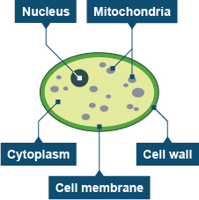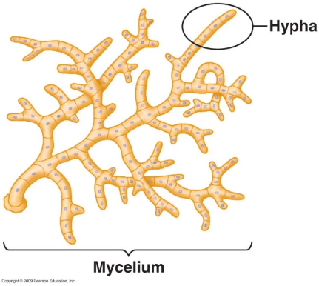Some fungi are **unicellular** (eg: yeast) whereas others are **multicellular** (eg: moulds). Multicellular fungi such as *Mucor* are often organised into a**mycelium**, a mesh of thread-like structures called **hyphae**.  Each hypha is a structure containing many nuclei.

**Cell structure**

Fungal cells are **eukaryotic**, having a nucleus and membrane-bound organelles (including mitochondria). They also have a cell wall made of a substance called **chitin** rather than cellulose.

**Nutrition**

Fungi are **heterotrophic** (ie: unable to manufacture their own food and obtain nutrients by taking in organic substances from their environment). They are therefore unable to photosynthesise and do not contain chloroplasts. Most fungi feed by secreting digestive enzymes onto the food material they are living on and then absorbing the products of digestion, a process of external digestion known as **saprotrophic nutrition**. Some fungi live as parasites and may cause disease (eg: athlete’s foot and Dutch elm disease).

Some fungi (especially yeasts) can undergo **anaerobic respiration** in the absence of oxygen to produce ethanol and carbon dioxide as waste products. This process (also known as **fermentation**) is the basis of brewing and baking.

**Ecological Importance**

Fungi perform an essential role in the **decomposition** of organic matter and have fundamental roles in nutrient cycling and exchange in the environment. For example, some fungi form mutualistic relationships with plant roots (known as **mycorrhiza**), helping to absorb nutrients from the soil in return for a supply of glucose for energy. Other fungi are associated with algae to form **lichens**, which play an important role in the colonisation of bare rock.

**Reproduction**

Some fungi reproduce sexually, although many reproduce asexually by producing **spores**. Mushrooms and toadstools are the fruiting bodies of moulds.

**Human importance**

Fungi have long been used as a direct source of human food (for example in the form of mushrooms and truffles), as a leavening agent for bread and in the fermentation of various food products (such as wine, beer, and soy sauce). Since the 1940s, fungi have been used for the production of antibiotics (eg: **penicillin**), and, more recently, various enzymes produced by fungi are used industrially and in detergents. Fungi are also used as biological pesticides to control weeds, plant diseases and insect pests.